

Case Study: Times-2 Speed Files®



Delta Airlines
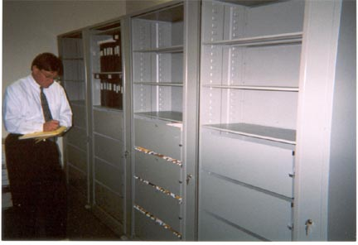
Corporate Headquarters
Atlanta, GA

Corporate Record Storage
- Legal
- Financial
- Human Resources

Delta Airlines was running out of space in their central filing department. They needed a way to secure files and store more in the same amount of space. Integrating mixed media into the storage system was an important goal.

The Challenges
Delta Airline’s Central Filing Department had lateral files that were functional, but just not doing the job. The staff needed more efficiency, higher capacity, and storage that was versatile. However, in an effort to save money it was mandatory that their top tab filing system be retained without conversion to another filing style.

The Solution
Times-2 Speed Files in a 7-Tier height were recommended and Delta Airlines agreed that this was the perfect solution.

Fifty Times-2 units replaced the old-style lateral system. The new locking, double-sided units provided increased storage. In fact, each 7-Tier Times-2 replaced the equivalent of 3.28 lateral files. Top tab filing was no problem either; the units were accessorized with drawers to accommodate this filing style. Binders and mixed media were stored in the unit’s top shelves as reflected in the photo above. Delta gained security for their confidential files, too: with one spin an open Times-2 closes and locks.

Delta’s requirements to increase storage, save office space, improve efficiency, and tighten security were met with the versatile Times-2 Speed Files.

